**Targeted use of charts**

**Introduction**

Microsoft Power BI is an excellent tool for creating interactive reports. An integral part of it, is its wide array of visual tools that allow you to represent data in a meaningful and accessible manner. However, a specific chart may not be helpful to all audiences. For example, the HR department has different data needs than the sales department. Similarly, charts created for the marketing department may not have any key points of interest for the IT department. This is where targeted charts come in.

In this reading, you will learn about targeted charts and the importance of targeting your use of charts in reports based on your audience’s data needs. This reading will also introduce you to key performance indicators (KPIs) and using KPIs to create targeted charts.

**Targeted charts and their importance**

A targeted chart is a data visualization designed for a particular audience, focusing on the most relevant data points. Creating a targeted chart involves understanding the audience's informational needs, selecting the most suitable chart type, and highlighting the data points of most interest to the audience. Simply put, a targeted chart is like a picture showing vital information for a particular group. Let’s outline why it’s important to use targeted charts in reports rather than generic ones. Targeted charts are:

* **Easier to understand**: When a chart only displays information that matters to a group of people, it’s easier for them to understand and interpret the information. They do not have to spend time on information that is not important to them.
* **More interesting**: If a chart contains information people care about, they are more likely to pay attention to it. This can lead to deeper thinking and discussion about the information in the chart.
* **More focused**: With targeted charts, people can focus on valuable information to make informed decisions. For instance, a chart showing sales over time can help a shop owner decide when to sell more particular items.
* **Clearer**: By showing only what's needed, targeted charts help avoid confusion. Everyone can clearly identify and understand the most critical points.
* **Time-saving**: Targeted charts help save time as they cut out unnecessary details. This means people can quickly grasp the key points and use this knowledge in their work and decision-making processes.

**Examples of targeted charts**

Let's explore some targeted charts using relevant data points from the same dataset for the Human Resources (HR), Marketing, and Sales departments at Adventure Works.

**Chart representing employee turnover rate for HR**

The HR department is interested in insights, patterns, and trends related to employee engagement and retention. The following sample dataset represents the number of employees leaving each department per month.

| **Department** | **Jan** | **Feb** | **Mar** | **Apr** | **May** |
| --- | --- | --- | --- | --- | --- |
| IT | 3 | 1 | 4 | 2 | 2 |
| Sales | 4 | 2 | 5 | 3 | 3 |
| Marketing | 2 | 2 | 1 | 2 | 3 |
| HR | 1 | 1 | 1 | 0 | 2 |
| Finance | 2 | 3 | 3 | 2 | 1 |

A suitable chart for this data is a clustered bar or column chart as these types of charts display information in a grouped fashion. Each column or bar on the chart represents a department. In the targeted chart displayed in the screenshot below, the **x-axis** represents the months (from January to May), while the **y-axis** represents the number of employees who left each department. With this visual representation of the data, HR can quickly identify departments with a higher turnover rate that may require intervention to improve employee retention.

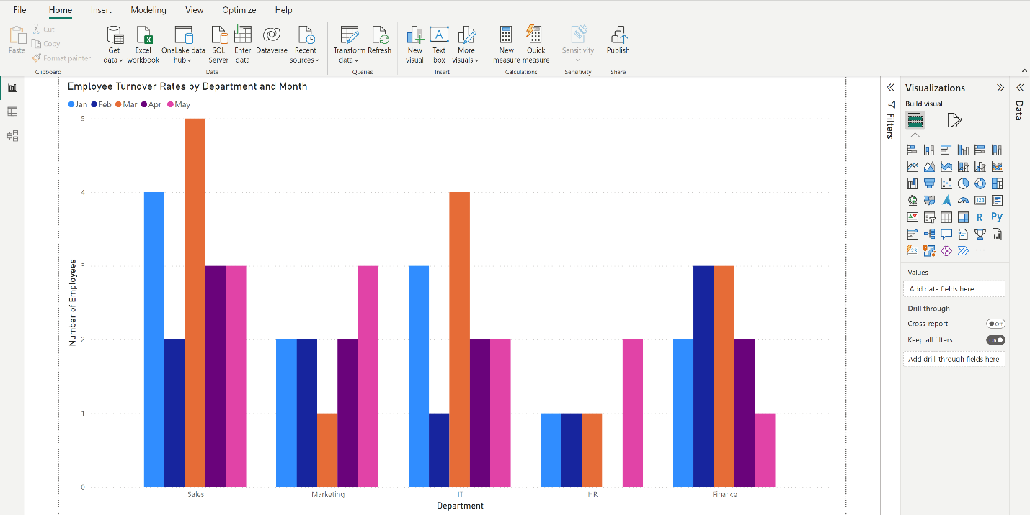

**Chart representing customer acquisition cost for Marketing**

Because the marketing department has its own area of focus, marketing, it is vital to identify data points that are relevant to this particular audience. This may include data on customer acquisition and engagement metrics. For example, you can use the table below, representing the customer acquisition cost per channel for a five-month period, to create a chart that’s relevant to the marketing department.

| **Month** | **Email Marketing** | **Social Media** | **SEO** | **PPC** |
| --- | --- | --- | --- | --- |
| Jan | 200 | 150 | 300 | 350 |
| Feb | 180 | 160 | 290 | 360 |
| Mar | 210 | 170 | 310 | 370 |
| Apr | 220 | 140 | 320 | 380 |
| May | 230 | 130 | 330 | 390 |

For visualizing this dataset, a line chart is an ideal choice. The **x-axis** represents the months, and the **y-axis** represents the customer acquisition cost. Each line on the chart signifies a different marketing channel. With this targeted chart, the marketing team can compare the cost efficiency of each channel over time, providing insights into which channels provide the best return on investment (ROI).

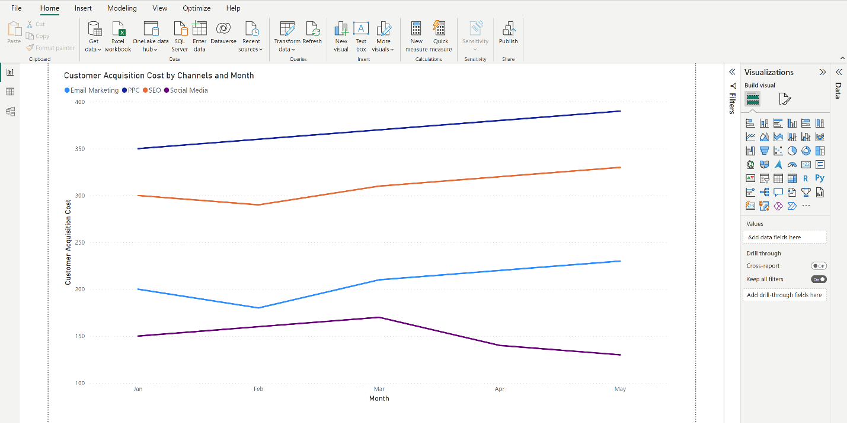

**Chart representing monthly figures for Sales**

The sales department is interested in sales performance metrics. You can use data like the monthly sales data in the table below to create charts that offer relevant insights.

| **Month** | **Sales (in US dollars)** |
| --- | --- |
| Jan | 12000 |
| Feb | 15000 |
| Mar | 18000 |
| Apr | 16000 |
| May | 19000 |

A simple line chart can effectively represent this data. The **x-axis** represents the months (from January to May), and the **y-axis** represents the sales figures. The line chart provides an easily understandable visual track of sales growth over time. This can help the sales team identify patterns, understand trends, and predict future sales.

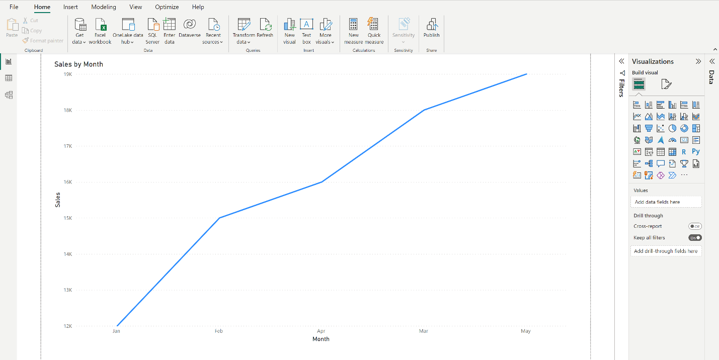

In each scenario, the charts are targeted because they are specifically designed to highlight the relevant Key Performance Indicators or KPIs for each department's goals and challenges, enabling data-driven decision-making.

**Understanding KPIs**

KPIs are quantifiable measurements that help an organization gauge its performance over time. These indicators are related to the organization's critical success factors and are often tied to strategic objectives. KPIs serve as a navigational tool that helps a company determine whether it is on the right track to achieving its goals.

KPIs play a significant role in Power BI and the targeted use of charts. The ability to visualize KPIs can make them more understandable and actionable for stakeholders, providing insights that can drive strategic decision-making. Let's explore how to align KPIs with the targeted use of charts based on the three audience groups discussed in the previous section: HR, Marketing, and Sales.

**HR KPIs**

HR might focus on KPIs such as employee turnover rate, the number of employees in each department, or the average time to fill a vacancy. Using charts that target these KPIs, such as in the stacked bar chart representing employee turnover rate by department, will ensure the relevance and usefulness of insights from your data report. For example, a pie chart displaying the distribution of employees across departments can also help visualize a critical KPI. It can enable the HR team to monitor the company's internal structure and take necessary actions if any imbalances are detected.

**Marketing KPIs**

For marketing, KPIs might include customer acquisition cost, conversion rates, or customer satisfaction score. Earlier in this reading, you explored creating a line chart to represent customer acquisition cost by marketing channel. Another example of a targeted chart based on KPIs is a bar chart to represent customer satisfaction scores across various product categories. In this case, the chart helps visualize another KPI (the customer satisfaction score), allowing the marketing team to monitor and work towards improving this key indicator.

**Sales KPIs**

The sales team might track KPIs such as monthly sales figures, sales growth, and sales target achievement. A line chart representing monthly sales over a year visually represents these KPIs. It allows the sales team to monitor these KPIs closely and strategize to enhance sales performance.

The sales conversion rate is an important KPI for businesses. It helps to measure the effectiveness of their sales efforts. Sales conversion rate is the percentage of how many potential customers or leads have converted into actual customers. Using this KPI, the sales team can understand how the opportunities are turning into revenues.

Remember, the best KPIs to use can change depending on the company's goals, who the end users of your analysis are, and what your report and its insights are being used for. It is key to pick KPIs that help reach the company’s main goals and improve how the company works.

**Conclusion**

Using KPIs to create targeted charts enables an audience to focus on the information most relevant to them. By learning about targeted charts and KPIs, you can help your stakeholders interpret patterns and trends and help them to reach decisions faster.